1. Problem Statement
Group projects are commonly used in universities to develop teamwork and collaboration skills among students. However, evaluating individual performance in group assignments is often difficult for teachers. In many cases, a small number of students complete most of the project work, while some members contribute very little. Despite the unequal participation, all students usually receive the same marks. This creates dissatisfaction among active students and reduces accountability within the team.
Although tools like GitHub can track code commits, they cannot fully measure other important activities such as communication, attendance, teamwork, and task participation. Manual peer evaluations are also not always reliable because they may be biased or incomplete.
From the students' perspective, participation in group projects is often hindered by a lack of transparency in grading, no clear breakdown of individual contributions, and uncertainty regarding how their efforts translate into final grades. Moreover, teachers lack a centralized system to monitor group dynamics in real-time, identify low contributors early, and generate fair, data-driven evaluation reports.
To overcome these limitations, there is a pressing need for a centralized, secure, and automated group project management solution. The proposed GroupSync system aims to address these challenges by providing a web-based, role-driven platform that supports secure authentication, course and group management, GitHub activity integration, peer review submission, automatic contribution scoring, and transparent report generation. By integrating attendance tracking, working hours, and analytics, the system seeks to enhance fairness, accountability, and efficiency throughout the entire group project lifecycle.
2. Inception
2.1 Introduction
Inception is the initial and foundational phase of the requirements engineering process. Its primary purpose is to establish a clear understanding of the problem domain, define the scope of the software system, and identify the needs, expectations, and constraints of all relevant stakeholders. During this phase, the development team works closely with stakeholders to gather initial requirements, identify potential risks, and ensure that the project has a clear direction before proceeding to detailed analysis and design.
For the proposed GroupSync – Intelligent Group Project Management with Contribution Analytics system, the inception phase was conducted to thoroughly understand the challenges associated with evaluating individual contributions in university group projects. The team analyzed existing manual and semi-digital evaluation methods, identified stakeholder concerns regarding fairness and transparency, and defined the overall feasibility of developing a centralized, role-driven platform.
The inception activities for GroupSync were organized around the following four aspects:
- Identifying Stakeholders
- Recognizing Multiple Viewpoints
- Working Towards Collaboration
- Asking the First Questions

2.2 Identifying Stakeholders
A stakeholder refers to any individual, group, or organization that is directly or indirectly affected by the development, implementation, or operation of a system. Stakeholders include end-users who interact with the system, as well as other parties whose workflows, decisions, or responsibilities may be influenced by the system’s outcomes.
To identify the stakeholders of the GroupSync System, the development team analyzed the academic group project environment within a university setting. The identification process focused on understanding who uses the system, who benefits from its outputs, who manages its operations, and whose work is affected by its implementation.
Based on this analysis, the following stakeholders were identified for the GroupSync System:
1. Students (Team Members)
Students are the primary end-users of the system. They participate in group projects, collaborate with team members, submit peer reviews, connect their GitHub repositories, and track their individual contribution scores. Their primary interest is a fair, transparent, and easy-to-use system that recognizes their efforts accurately.
2. Teachers (Professors / Course Instructors)
Teachers are responsible for designing group project assignments, evaluating student performance, and assigning final grades. They use the system to create courses, set evaluation weightage, monitor group progress, generate reports, and identify low-contributing students. Their primary concern is having reliable, data-driven insights to support fair grading.
3. System Administrator (Admin)
The system administrator manages user accounts, assigns roles, monitors platform-wide activities, and ensures system security and stability. This stakeholder plays a critical role in maintaining data integrity, handling support requests, and configuring system-wide parameters.
4. University Administration
University administration oversees academic policies, grading standards, and institutional governance. Although they may not directly use the system, they are indirectly affected by its outcomes, as the credibility and fairness of project evaluations reflect on the institution’s academic integrity and policy enforcement.
5. System Developers
The development team is responsible for system design, implementation, testing, deployment, and future enhancements. Their work is influenced by requirements clarity, scalability demands, security considerations, and performance expectations.
6. System Operators
System operators are responsible for day-to-day technical operations, including monitoring system performance, managing backups, ensuring high availability during peak submission periods, and handling routine maintenance tasks.
2.3 Viewpoints of Stakeholders
Different stakeholders have distinct expectations, priorities, and concerns regarding the GroupSync System. Understanding these viewpoints is essential to capture a complete, realistic, and conflict-free set of system requirements.
2.3.1 System Administrator (Admin) Viewpoints
- Centralized control over user accounts, roles, permissions, and platform-wide configurations.
- Ability to create, modify, and delete student and teacher accounts as needed.
- Strong authentication mechanisms and role-based access control to prevent unauthorized access.
- Real-time monitoring of system activities, active user sessions, and platform health.
- Access to detailed system logs and audit trails for security auditing and accountability.
- High system availability, especially during peer review deadlines and project submission periods.
- Capability to manage backup schedules and data recovery procedures.
2.3.2 Teachers (Professors) Viewpoints
- Easy and intuitive creation and management of courses, group project assignments, and deadlines.
- Ability to define and adjust evaluation weightage for different contribution metrics (e.g., GitHub commits, attendance, peer reviews, working hours).
- Clear visualization of each student’s individual contribution score (0-100) with a detailed breakdown.
- Automated flagging of students whose contribution score falls below a predefined threshold.
- Generation of downloadable reports (PDF and Excel formats) for final grading and record-keeping.
- Access to visual analytics dashboards showing contribution distribution, group comparisons, and low performers.
- Assurance that peer reviews are submitted anonymously and are free from bias.
- Ability to leave feedback or warnings for individual students or entire groups.
2.3.3 Students (Team Members) Viewpoints
- A simple, clean, and user-friendly interface for managing group activities and tracking contributions.
- Secure login and clear visibility of personal contribution breakdown (commits, attendance, peer review ratings, working hours).
- Ability to create a new group or join an existing group using a unique invitation code.
- Ability to connect their GitHub repository and automatically track commit activity.
- Assurance that submitted peer reviews remain anonymous and will not affect team relationships negatively.
- Confidence that their hard work will be recognized and fairly evaluated.
- Receive timely notifications for pending peer reviews, low contribution scores, or teacher feedback.
- Access to a personal dashboard showing contribution trends over time.
2.3.4 University Administration Viewpoints
- Credibility, fairness, and integrity of the overall project evaluation process across all courses.
- A structured, rule-based, and data-driven assessment of student collaboration and teamwork skills.
- Availability of audit records and historical reports for accountability and dispute resolution.
- Minimization of legal, reputational, and academic risks associated with unfair grading complaints.
- Reliable and consistent evaluation outcomes that support institutional decision-making.
2.3.5 System Developers Viewpoints
- Clear, unambiguous, and well-documented system requirements.
- Scalable and modular system architecture (e.g., Laravel/Node.js backend, MySQL database, React.js frontend).
- Efficient performance during high concurrent usage, particularly near submission deadlines.
- Secure implementation following industry best practices (e.g., password hashing, input validation, API security).
- Well-documented REST APIs for GitHub integration and internal operations.
- Support for comprehensive testing, debugging, and future feature enhancements.
2.3.6 System Operators Viewpoints
- Easy maintainability through modular code structure, clear documentation, and standardized deployment procedures.
- Availability of monitoring tools, error logs, and health checks for quick issue resolution.
- Reliable backup and recovery mechanisms to prevent loss of contribution data.
- Stable system operation throughout the academic semester, especially during critical periods.
- Safe deployment of updates and patches with minimal downtime.
2.4 Working Towards Collaboration
Because different stakeholders have diverse and sometimes conflicting expectations, a collaborative requirements consolidation process was conducted. The objective was to merge stakeholder needs into a coherent, practical, and mutually acceptable set of initial system requirements.
The following steps were followed to complete this task:
- Identification of common and conflicting requirements across all stakeholder groups.
- Categorization of requirements based on functionality, security, usability, and governance.
- Assignment of priority points to each requirement through stakeholder discussions and voting.
- Final decision-making based on priority, technical feasibility, and project scope.
2.4.1 Common Requirements
The following requirements were identified as common across most stakeholder groups:
- A user-friendly, intuitive, and efficient system interface.
- Secure and reliable system operation with minimal downtime.
- Role-based access control to ensure appropriate permissions.
- Internet-based accessibility from approved devices and locations.
- Accurate, transparent, and automated generation of contribution scores.
2.4.2 Conflicting Requirements
Some requirements differed across stakeholders due to varying responsibilities and priorities. These conflicts were identified and resolved through negotiation and prioritization:
Conflicting Area | Stakeholder Concern
System complexity vs. advanced analytics | Teachers requested detailed analytics (charts, trends, comparisons), while developers preferred a simpler implementation due to time constraints.
Ease of access vs. strict permissions | Students wanted quick and easy access, while Admins and Teachers demanded strict role-based restrictions to protect data integrity.
Feature completeness vs. budget/time | All stakeholders desired a full feature set, but budget and timeline limitations required prioritization of core features.
Peer review flexibility vs. bias prevention | Students wanted flexible peer review submission, while Teachers expressed concern about potential biased or dishonest reviews.
Resolution Approach:
These conflicts were resolved through structured discussions, prioritization matrices, and consensus-building. Critical requirements related to security, core functionality (score calculation, GitHub integration), and fairness (anonymous peer review, audit logs) were given the highest priority. Advanced analytics and visualization features were planned for later sprints or future enhancements.
2.4.3 Initial Final Requirements
Based on the collaborative analysis, prioritization process, and feasibility assessment, the following 20 initial final requirements were agreed upon for the GroupSync System:
- The system shall be accessible via the Internet during the entire academic semester.
- The system shall allow valid users (Students, Teachers, Admins) to securely log in and log out using authenticated credentials.
- The system shall restrict access to system functionalities based on predefined user roles (Student, Teacher, Admin).
- The system shall allow Teachers to create, configure, and manage courses and group project assignments.
- The system shall allow Students to create new project groups and generate a unique invitation code for team members.
- The system shall allow Students to join an existing group by entering a valid invitation code.
- The system shall allow Students to connect their GitHub repository to their group for automated activity tracking.
- The system shall ensure that each student can belong to only one group per project assignment.
- The system shall automatically fetch commit history, repository activity, and push frequency using the GitHub REST API.
- The system shall allow Students to submit anonymous peer reviews for each of their team members based on communication, reliability, and task participation.
- The system shall ensure that peer review ratings and comments remain anonymous to other students but visible to Teachers.
- The system shall allow Teachers to define and adjust weightage percentages for contribution metrics (GitHub commits, attendance records, peer reviews, logged working hours).
- The system shall automatically calculate an individual contribution score (on a scale of 0 to 100) for each student based on the defined weightage and collected data.
- The system shall provide Students with a visual dashboard showing their personal contribution score and a detailed breakdown of how it was calculated.
- The system shall automatically flag students whose contribution score falls below a teacher-defined threshold and notify the Teacher.
- The system shall provide Teachers with visual analytics dashboards, including contribution distribution charts, group comparisons, and low performer lists.
- The system shall allow Teachers to generate and download contribution reports in PDF and Excel formats for final grading.
- The system shall allow Administrators to view, add, edit, and delete user accounts (Students and Teachers) and monitor platform activities.
- The system shall maintain detailed audit logs of user activities, administrative actions, and system events to ensure accountability and support forensic analysis.
- The system shall support automated backup and recovery mechanisms to prevent data loss in case of system failure.

2.5 Asking the First Questions
The initial phase of stakeholder interaction involved asking a structured set of context-free questions to clarify project objectives, identify stakeholder expectations, and define system boundaries. These questions were organized into three categories:
Category 1: Stakeholder and Goal Identification
- Who are the primary users of the GroupSync System?
- What problems does the system aim to solve?
- What are the expected benefits for students, teachers, and administrators?
- Are there any existing systems or manual processes currently being used?
Category 2: Scope and Feasibility
- What are the must-have features versus nice-to-have features?
- What are the technical constraints (e.g., hosting, API rate limits, browser compatibility)?
- Is the project feasible within the given timeline (4 weeks) and team size (6 members)?
- What third-party integrations (e.g., GitHub API) are required?
Category 3: Requirement Clarity and Communication
- Are the requirements clearly understood by all stakeholders?
- Are there any ambiguous or conflicting requirements that need further discussion?
- How will changes to requirements be managed during development?
- How will the development team communicate progress back to stakeholders?
The answers to these questions helped the development team:
- Confirm that the core problem (unfair grading in group projects) was valid and widely recognized.
- Prioritize features such as GitHub integration, contribution scoring, peer review submission, and report generation.
- Identify potential risks, including GitHub API rate limits, biased peer reviews, and hosting limitations.
- Establish a shared understanding of system scope, preventing scope creep during later development phases.
By completing the inception phase with these structured questions and stakeholder discussions, the GroupSync project team established a solid foundation for requirements elicitation, analysis, and subsequent modeling activities.
3. Elicitation
3.1 Introduction
Requirements elicitation is a critical and systematic phase in the software development life cycle. Its primary purpose is to discover, understand, define, and document the needs and expectations of stakeholders regarding the proposed software system. Unlike the inception phase, which focuses on initial problem understanding and high-level scoping, the elicitation phase involves deeper investigation, structured collaboration, and formal documentation of functional and non-functional requirements.
During the elicitation phase, several challenges are commonly encountered, including:
- Unclear or evolving project scope
- Conflicting stakeholder expectations
- Difficulty articulating needs by non-technical stakeholders
- Gaps in understanding between stakeholders and developers
- Requirement volatility due to changing academic or technical environments
To overcome these challenges in the GroupSync – Intelligent Group Project Management with Contribution Analytics project, the elicitation process was carried out in a structured, collaborative, and iterative manner. The development team emphasized close interaction with students, teachers, and administrative representatives to ensure that both functional requirements (what the system must do) and non-functional requirements (how well the system must perform) were accurately captured, validated, and prioritized.
By following an organized elicitation approach, the project team aimed to:
- Reduce ambiguity and misinterpretation of requirements
- Manage requirement changes systematically
- Build a clear, validated foundation for system design and implementation
- Ensure that the final system addresses real academic project management needs
The elicitation phase for GroupSync was organized around the following four core activities:
- Collaborative Requirements Gathering
- Quality Function Deployment (QFD)
- Usage Scenarios
- Elicitation Work Products

3.2 Eliciting Requirements
Unlike the inception phase, which primarily relies on a question-and-answer approach to establish initial scope, the elicitation phase for GroupSync combined multiple complementary techniques to ensure comprehensive requirement discovery. These techniques were applied iteratively, allowing the team to refine and elaborate requirements as understanding deepened.
The following activities were performed during the elicitation phase:
Activity | Purpose | Methods Used
Collaborative Requirements Gathering | To collect raw requirements through direct stakeholder interaction | Focus group discussions, interviews, surveys
Quality Function Deployment (QFD) | To categorize requirements into normal, expected, and exciting levels | Prioritization matrices, stakeholder voting
Usage Scenarios | To understand real-world system interactions and edge cases | Scenario writing, walkthroughs, exception analysis
Elicitation Work Products | To formally document and validate elicited requirements | Requirement specification tables, scope statements, environment descriptions

Each of these activities is described in detail in the following subsections.

3.3 Collaborative Requirements Gathering
Collaborative requirements gathering was conducted to clearly understand the needs, expectations, and pain points of all stakeholders involved in the GroupSync System. The development team recognized that effective requirements cannot be developed in isolation; instead, they emerge through structured dialogue and shared understanding between developers and stakeholders.

Participants Involved:
Stakeholder Group | Number of Participants | Role in Elicitation
Students | 12 (from different departments and semesters) | Provided feedback on existing group project challenges, desired features, and usability expectations
Teachers | 4 (from CSE and other departments) | Shared experiences with unfair grading, manual evaluation difficulties, and reporting needs
System Administrator (simulated) | 2 (team members acting in admin role) | Identified security, user management, and audit requirements
University Administration Representative | 1 (academic advisor) | Provided input on institutional policies, data privacy, and grading compliance

Elicitation Methods Used:
- Semi-Structured Interviews: Individual interviews were conducted with two teachers and four students to explore their experiences with group project evaluation in depth. Each interview lasted approximately 30-45 minutes.
- Focus Group Discussion: A 90-minute focus group session was held with 8 students and 2 teachers to discuss common challenges, brainstorm feature ideas, and identify conflicting expectations. The discussion was moderated by the team leader, and notes were recorded by the documentation team.
- Online Survey: A structured questionnaire was distributed to 45 students across multiple semesters to collect quantitative data on:
  - Frequency of unfair grading experiences
  - Willingness to submit anonymous peer reviews
  - Preferred features for a contribution tracking system
  - Technical familiarity (GitHub, version control, etc.)

Key Findings from Collaborative Gathering:
Identified Issue | Stakeholder Source | Implication for GroupSync
"Some team members do almost nothing, yet get the same grade as me." | Students (multiple) | Contribution score must differentiate individual efforts
"I have no way to track who did what after the project is submitted." | Teachers | Real-time dashboards and activity logs are essential
"I would review my teammates honestly if it was anonymous." | Students | Anonymous peer review mechanism is critical
"Manually collecting attendance and GitHub links is time-consuming." | Teachers | Automated GitHub integration and attendance tracking required
"I don't know how my final grade was calculated from group work." | Students | Transparent score breakdown must be visible to each student
"The system must comply with university grading policies." | Administration | Configurable weightage and audit trails are mandatory

Based on the feedback and discussions, the project team analyzed the collected information and finalized a comprehensive, prioritized list of system requirements for GroupSync. These requirements were then categorized using Quality Function Deployment (QFD), as described in the following section.

3.4 Quality Function Deployment (QFD)
Quality Function Deployment (QFD) is a systematic technique used to translate stakeholder needs, expectations, and desires into structured, actionable system requirements. It helps development teams understand which features are mandatory (normal), which are expected but not explicitly stated (expected), and which are innovative and delightful (exciting). By categorizing requirements, the team can balance functionality, usability, and innovation within project constraints.
For the GroupSync System, requirements were categorized into three distinct levels:
Category | Definition | Priority
Normal Requirements | Basic, explicitly stated features that the system must have to be acceptable. Absence causes dissatisfaction. | High (Mandatory)
Expected Requirements | Implicit features that users assume will be present. Not always stated but sorely missed if absent. | High (Implicit)
Exciting Requirements | Innovative, unexpected features that delight users. Their absence does not cause dissatisfaction. | Medium (If feasible
3.4.1 Normal Requirements
Normal requirements represent the core, non-negotiable functionalities of the GroupSync System. These requirements were explicitly requested by stakeholders during interviews and focus group sessions. Without these features, the system would be considered incomplete or unacceptable.
Authentication and Access Control:
- The system shall allow Students to register using their university email address.
- The system shall allow Teachers and Admins to register using institutional email credentials.
- The system shall provide secure login and logout functionality for all user roles.
- The system shall allow users to change their passwords after successful authentication.
- The system shall enforce role-based access control (Student, Teacher, Admin) throughout all interfaces.
User Management (Admin):
- The system shall allow Admin to view, add, edit, and delete student accounts.
- The system shall allow Admin to view, add, edit, and delete teacher accounts.
- The system shall allow Admin to assign and modify user roles as needed.
Course and Group Management:
- The system shall allow Teachers to create new courses with course code, title, and semester information.
- The system shall allow Teachers to enroll students manually or via self-enrollment using a course code.
- The system shall allow Students to create a new project group and receive a unique invitation code.
- The system shall allow Students to join an existing group by entering a valid invitation code.
- The system shall prevent a student from belonging to more than one group per project assignment.
GitHub Integration:
- The system shall allow Students to connect their personal GitHub account to the platform.
- The system shall allow Students to link a specific repository to their project group.
- The system shall automatically fetch commit history, repository activity, and push frequency using the GitHub REST API.
- The system shall prevent the same GitHub repository from being linked to multiple groups.
Contribution Tracking and Scoring:
- The system shall allow Teachers to define weightage percentages for contribution metrics (commits, attendance, peer reviews, working hours).
- The system shall validate that total weightage equals 100% before saving.
- The system shall automatically calculate an individual contribution score (0-100) for each student based on the defined weightage and collected data.
- The system shall provide Students with a visual dashboard showing their personal contribution score and detailed breakdown.
Peer Review System:
- The system shall allow Students to submit anonymous peer reviews for each of their team members.
- The system shall require ratings for communication, reliability, and task participation.
- The system shall allow optional text comments to accompany ratings.
- The system shall prevent a student from submitting more than one peer review per team member per project.
Reporting and Analytics:
- The system shall allow Teachers to generate downloadable contribution reports in PDF and Excel formats.
- The system shall provide Teachers with visual analytics dashboards (charts and graphs) showing contribution distribution.
- The system shall automatically flag students whose contribution score falls below a teacher-defined threshold.
System Administration:
- The system shall maintain audit logs of user activities, administrative actions, and system events.
- The system shall support automated backup and recovery mechanisms.
- The system shall be accessible through a responsive, web-based interface.
- The system shall operate on a centralized server infrastructure.
3.4.2 Expected Requirements
Expected requirements are features that stakeholders implicitly assume will be present in a well-designed system. These requirements are often not stated explicitly during interviews because users consider them standard or obvious. However, their absence would cause significant dissatisfaction and make the system feel incomplete or unprofessional.
- Data Persistence and Integrity: The system shall maintain a centralized, secure, and consistent database for storing all user profiles, courses, groups, contribution data, peer reviews, and system logs.
- Automatic Role-Based UI Adaptation: The system shall automatically adjust menus, dashboards, and available actions based on the logged-in user's role (Student, Teacher, Admin) without requiring manual configuration.
- Secure Credential Storage: The system shall encrypt all user passwords using a strong hashing algorithm (e.g., bcrypt) and shall never store plain-text passwords.
- Duplicate Prevention: The system shall ensure that a student can cast only one peer review per team member and can belong to only one group per project.
- Data Separation for Anonymity: The system shall separate identifying information (student name, email) from peer review ratings and comments to ensure true anonymity from other students.
- Deadline Enforcement: The system shall automatically enforce peer review deadlines by disabling submission functionality after the teacher-defined cutoff date.
- Anti-Tampering Measures: The system shall prevent modification or deletion of submitted peer reviews and contribution data after the deadline has passed.
- Automated Score Calculation: The system shall automatically recalculate contribution scores whenever new data is available (e.g., new commits, submitted peer reviews).
- Threshold-Based Alerts: The system shall automatically notify Teachers when a student's contribution score drops below the defined threshold without requiring manual checking.
- Concurrent User Support: The system shall maintain data consistency and stable performance when multiple users (e.g., 50+ students) access the system simultaneously during peak submission periods.
- Input Validation and Sanitization: The system shall validate all user inputs (forms, API calls) and sanitize data to prevent SQL injection, cross-site scripting (XSS), and other common security vulnerabilities.
- Consistent User Interface: The system shall provide a consistent look, feel, and navigation structure across all user roles and device sizes (desktop, tablet, mobile).
- Session Management: The system shall automatically terminate inactive user sessions after a predefined timeout period (e.g., 30 minutes) and require re-authentication for sensitive operations.
- Error Handling and User Feedback: The system shall display clear, user-friendly error messages (e.g., "Invalid email or password") without exposing technical details or stack traces.
- Data Export Capability: The system shall allow Teachers to export raw contribution data (CSV format) for external analysis or record-keeping.
3.4.3 Exciting Requirements
Exciting requirements are innovative features that go beyond stakeholder expectations. These features are not requested during initial discussions because users may not realize they are possible. When present, exciting requirements generate delight and positive surprise. However, their absence does not cause dissatisfaction, as users did not expect them in the first place.
For the GroupSync System, the following exciting requirements were identified as potential differentiators that could significantly enhance user experience and system value:
- Real-Time Contribution Score Gauge: Display a dynamic, color-coded gauge (e.g., 0-100 with green/yellow/red zones) on the Student dashboard that updates in real-time as new commits are pushed or peer reviews are submitted.
- Contribution Trend Over Time: Provide Students with a line chart showing how their contribution score has evolved over the duration of the project (e.g., Week 1, Week 2, Week 3), helping them visualize improvement or decline.
- Automated Peer Review Reminders: Send automated email or in-app notifications to Students who have not yet submitted their peer reviews, with configurable reminders (e.g., 3 days before deadline, 1 day before deadline).
- Teacher Preview Mode for Reports: Allow Teachers to preview how a report will look (PDF/Excel) before finalizing and sharing with students or administration, including the ability to add comments or adjustments.
- Group Activity Heatmap: Display a visual heatmap (calendar-style) showing daily commit activity, peer review submissions, and logged hours for each group, helping Teachers quickly identify active and inactive periods.
- Comparison View for Teachers: Allow Teachers to compare two or more groups side-by-side in the analytics dashboard, showing average contribution scores, commit frequency, and peer review completion rates.
- GitHub Commit Quality Analysis: Go beyond commit count by analyzing commit message quality, consistency, and distribution across team members (e.g., did one student make 100 commits in one day vs. 10 commits over 10 days).
- Student Leaderboard (Anonymous): Display an anonymized leaderboard showing contribution score percentiles, allowing Students to see how they rank compared to peers without revealing specific identities.
- Automated Low-Contributor Warning to Student: When a student's contribution score drops below the threshold, automatically send a private, constructive notification to the student (e.g., "Your contribution score has dropped below 40%. Consider increasing activity or communicating with your team.").
- Exportable Audit Logs for Administration: Allow Administrators to export audit logs in structured formats (JSON, CSV) for external compliance review or long-term archival.
Prioritization Note: Due to the 4-week development timeline and team size of six members, exciting requirements were prioritized for implementation only after all normal and expected requirements were completed. Selected high-value exciting features (such as the real-time score gauge and automated reminders) were planned for the final sprint if time permitted. Remaining exciting requirements were documented for future enhancement phases.

3.5 Usage Scenarios
Usage scenarios (also known as use case scenarios or narrative descriptions) are detailed, step-by-step descriptions of how specific users interact with a system to accomplish a goal. These scenarios cover both normal (expected) and exceptional (error, boundary, or malicious) situations. Developing usage scenarios helps the development team:
- Validate requirements against real-world situations
- Identify missing requirements or edge cases
- Understand system behavior under error conditions
- Design appropriate error messages and recovery mechanisms
The following usage scenarios were developed for the GroupSync System based on stakeholder interviews, focus group discussions, and risk analysis.
3.5.1 Scenario 1: Invalid Login Attempt
Description: A user attempts to access the system using incorrect credentials.
Actors: Student, Teacher, or Admin
Normal Flow:
- User navigates to the GroupSync login page.
- User enters an incorrect username/email and/or password.
- User submits the login form.
- System validates the credentials against the database.
- System rejects the authentication request.
- System displays an error message: "Invalid email or password. Please try again."
- User remains on the login page.
Exceptional Flow (Multiple Failures):
- User attempts to log in with incorrect credentials five times consecutively.
- System detects repeated failed attempts from the same IP address or user account.
- System temporarily blocks the user account for 15 minutes.
- System displays a message: "Too many failed attempts. Your account has been temporarily locked. Please try again after 15 minutes or contact support."
- System records the failed attempts and lockout event in the audit log for security auditing.
Post-Condition: User is not granted access to the system. All failed attempts are logged.

3.5.2 Scenario 2: Unauthorized Access Attempt
Description: A logged-in user attempts to access a function or page that is outside their assigned role's permissions.
Actors: Student, Teacher, or Admin
Normal Flow:
- A Student is logged into the GroupSync System.
- The Student manually types the URL for the Teacher's Analytics Dashboard (e.g., /teacher/analytics) into the browser address bar.
- Student presses Enter to navigate.
- System receives the request and extracts the user's role from the active session.
- System verifies that the requested resource requires the "Teacher" role.
- System detects a role mismatch (current role is "Student").
- System denies access to the requested page.
- System displays a warning message: "Access Denied. You do not have permission to view this page."
- System logs the unauthorized access attempt in the audit log, including user ID, timestamp, requested URL, and source IP address.
- System redirects the Student back to their appropriate dashboard.
Post-Condition: Unauthorized access is prevented and recorded. User remains within their authorized boundaries.

3.5.3 Scenario 3: Late Peer Review Submission
Description: A student attempts to submit a peer review after the teacher-defined deadline has passed.
Actors: Student, System
Normal Flow:
- Teacher creates a project assignment and sets the peer review deadline to May 25, 2026, at 11:59 PM.
- Current system date and time is May 26, 2026, at 10:00 AM (deadline has passed).
- Student logs into GroupSync and navigates to the Peer Review section.
- Student selects a team member and fills out the rating and comment fields.
- Student clicks the "Submit Review" button.
- System checks the current server time against the assignment's peer review deadline.
- System determines that the current time is after the deadline.
- System rejects the submission.
- System displays a message: "Peer review deadline has passed (May 25, 2026, 11:59 PM). Submissions are no longer accepted."
- System does not save the review.
- System logs the attempted late submission in the audit log.
Alternative Flow (Grace Period if configured):
- If Teacher has configured a grace period (e.g., 24 hours), System may allow late submission but mark it as "Late" in the report.
Post-Condition: Peer review is not submitted. Student is informed of deadline expiration.

3.5.4 Scenario 4: Duplicate GitHub Repository Connection
Description: A student attempts to connect a GitHub repository that is already linked to another group in the same course and project assignment.
Actors: Student, System
Normal Flow:
- Student A from Group Alpha connects repository "project-x" to their group.
- System successfully links the repository and records its unique repository ID.
- Student B from Group Beta later attempts to connect the same repository "project-x" to their group.
- Student B authorizes GitHub access and selects the repository.
- System checks the repository's unique ID against existing connections for the same course and assignment.
- System detects that the repository is already linked to Group Alpha.
- System rejects the connection request.
- System displays an error message: "This repository is already connected to another group in this course. Each repository can only be linked to one group."
- System logs the duplicate connection attempt in the audit log.
Post-Condition: Repository remains linked only to the original group. Second connection is rejected.

3.5.5 Scenario 5: System Failure During Active Submission
Description: A temporary system failure (e.g., database connection loss, server timeout) occurs while multiple students are actively submitting peer reviews or pushing commits.
Actors: Students, System, System Operator
Normal Flow:
- Students are actively submitting peer reviews during peak hours (e.g., 1 hour before deadline).
- A temporary database connection failure occurs due to high load.
- System detects the failure (e.g., database query timeout).
- System suspends ongoing write operations (submissions, updates) to prevent data corruption.
- System displays a user-friendly message to affected students: "System is experiencing high load. Your submission has been saved temporarily. Please try again in a few minutes."
- Background recovery mechanisms are activated automatically.
- Database connection is restored after 2 minutes.
- System verifies data integrity and consistency.
- System restores normal operation.
- Students can resume and complete their submissions.
Post-Condition: No submission data is lost, duplicated, or corrupted. System returns to full operation. Audit log records the failure and recovery events.

3.5.6 Scenario 6: Invalid Group Configuration
Description: A Teacher attempts to create or update a project assignment configuration with incomplete or invalid parameters.
Actors: Teacher, System
Normal Flow:
- Teacher creates a new project assignment titled "Software Engineering Group Project."
- Teacher sets weightage as follows: GitHub Commits = 40%, Attendance = 30%, Peer Reviews = 20% (Total = 90%).
- Teacher clicks "Save Configuration."
- System validates that total weightage equals 100%.
- System detects that total weightage is 90% (less than 100%).
- System rejects the configuration.
- System displays specific error messages:
  - "Total weightage must equal 100%. Current total: 90%."
  - "Please adjust the values to reach 100%."
- System does not save the invalid configuration.
- Teacher adjusts weightage: GitHub Commits = 40%, Attendance = 30%, Peer Reviews = 20%, Working Hours = 10% (Total = 100%).
- Teacher clicks "Save Configuration" again.
- System validates and accepts the configuration.
- System displays a success message: "Configuration saved successfully."
Post-Condition: Only valid, complete configurations are saved. Clear error messages guide correction.

3.5.7 Scenario 7: Malicious Activity Detection
Description: The system detects unusual or potentially malicious behavior, such as rapid repeated API calls, brute-force login attempts, or unusual data access patterns.
Actors: System, Attacker (external), System Administrator
Normal Flow:
- System continuously monitors request patterns, login attempts, and API usage.
- The system detects 100+ API calls to the GitHub integration endpoint from a single user within 60 seconds (well above normal usage).
- System flags the activity as "suspicious" and classifies it as a potential denial-of-service (DoS) or abuse attempt.
- System automatically restricts access for the involved user account for 30 minutes.
- System logs detailed activity records, including user ID, timestamps, endpoints accessed, request frequency, and source IP address.
- System sends an automated alert notification to the System Administrator via email or dashboard.
- Admin reviews the logs and determines appropriate action (e.g., permanent ban, password reset, contact user).
- System continues to monitor for similar patterns from other users.
Post-Condition: Potential malicious activity is contained. Audit trail is available for investigation. Admin is notified.

3.6 Elicitation Work Product
The output of the requirements elicitation process varies depending on the size, complexity, and nature of the system being developed. For the GroupSync System, the elicitation work products were carefully prepared to ensure clarity, completeness, traceability, and alignment with stakeholder expectations.
The following elicitation work products were delivered for the GroupSync project:
Work Product | Description | Purpose
Structured Requirements Statement | A clear, organized document listing all functional and non-functional requirements derived from stakeholder discussions. Includes normal, expected, and exciting categories. | Serves as the foundation for design, implementation, and testing.
Project Scope Statement | A well-defined description of system boundaries, including features that are included (e.g., GitHub integration, peer reviews, contribution scoring) and explicitly excluded (e.g., real-time chat, plagiarism detection). | Prevents scope creep and manages stakeholder expectations.
Stakeholder Register | A comprehensive list of all individuals and groups who participated in elicitation, including Students (12 participants), Teachers (4 participants), Administration (1 participant), and simulated Admin roles. | Ensures traceability and identifies points of contact for future validation.
Detailed Usage Scenarios | A set of 7 documented scenarios covering normal, error, and malicious conditions. Each scenario includes actors, flow, exceptions, and post-conditions. | Validates requirements against real-world situations and identifies edge cases.
Technical Environment Description | A specification of the system's technical environment, including web-based frontend (HTML5, TailwindCSS, React.js), backend (PHP/Laravel, Node.js), database (MySQL), GitHub REST API, deployment platform (InfinityFree), and version control (Git/GitHub). | Guides architectural decisions and technology selection.

Summary of Elicitation Outcomes:
By the conclusion of the elicitation phase, the GroupSync project team had achieved the following:
- Identified and documented 32 normal requirements, 15 expected requirements, and 10 exciting requirements.
- Validated all requirements with at least two stakeholder groups.
- Resolved initial conflicts (e.g., feature completeness vs. timeline) through prioritization.
- Established a clear technical direction based on stakeholder needs and team capabilities.
- Created a validated foundation for scenario-based modeling, data modeling, class-based modeling, and behavioral modeling in subsequent phases.
The elicitation work products served as the primary input for the remaining sections of this Software Requirements Specification (SRS) document, ensuring that the entire development process remains grounded in authentic stakeholder needs and validated requirements.
4. Scenario-Based Modeling
4.1 Use Case Scenario
Table 1: Use Cases Table

Level - 0 | Level - 1 | Level-2 | Actors
GroupSync | Authentication | Sign Up | Student
 |  | Sign In | Student, Teacher, Admin
 |  | Sign Out | Student, Teacher, Admin
 |  | Change Password | Student, Teacher, Admin
 | User Management | Create User | Admin
 |  | Update User Role | Admin
 |  | Delete User | Admin
 | Course & Group Management | Create Course | Teacher
 |  | Enroll Students | Teacher
 |  | Create Group | Student
 |  | Join Group | Student
 |  | Connect GitHub Repo | Student
 | Contribution Tracking | Set Weightage | Teacher
 |  | Fetch GitHub Activity | System
 |  | View Contribution Score | Student, Teacher
 | Peer Review Process | Submit Peer Review | Student
 |  | View Peer Review Status | Student
 | Report & Analytics | Generate Report | Teacher
 |  | View Analytics Dashboard | Teacher
 |  | Flag Low Contributors | System, Teacher
 | Monitoring & System Admin | View Audit Logs | Admin
 |  | Manage System Settings | Admin

4.2 Use Case Description
4.2.1 Authentication
1. Use Case: Sign Up
- Primary Actor: Student
- Goal: To create a new account.
- Preconditions: System is online. Student not registered.
- Trigger: Student wants to register.
- Scenario:
  - Student visits Sign Up page.
  - Student provides registration information (university email).
  - System validates information.
  - System creates a new student account.
  - Confirmation message is shown.
- Exceptions: Invalid information. Email already exists.
2. Use Case: Sign In
- Primary Actors: Student, Teacher, Admin
- Goal: To access the system.
- Precondition: User must be registered.
- Trigger: User wants to log in.
- Scenario:
  - User enters username and password.
  - System validates credentials.
  - System identifies user role.
  - User is redirected to respective dashboard.
- Exceptions: Invalid credentials. Account blocked.
3. Use Case: Sign Out
- Primary Actors: Student, Teacher, Admin
- Goal: To exit the system.
- Precondition: User must be logged in.
- Trigger: User wants to log out.
- Scenario:
  - User clicks Sign Out.
  - System terminates the session.
  - User is redirected to login page.
4. Use Case: Change Password
- Primary Actors: Student, Teacher, Admin
- Goal: To update account password.
- Precondition: User must be logged in.
- Trigger: User wants to change password.
- Scenario:
  - User opens Change Password option.
  - User enters old and new password.
  - System validates the new password.
  - Password is updated successfully.
- Exceptions: Weak password. Incorrect current password.
4.2.2 User Management
1. Use Case: Create User
- Primary Actor: Admin
- Goal: To create a new system user.
- Precondition: Admin must be logged in.
- Trigger: Admin needs to add a user.
- Scenario:
  - Admin opens User Management.
  - Admin selects Create User.
  - Admin enters user details and role (Student/Teacher).
  - System validates information.
  - User account is created.
- Exceptions: User already exists. Invalid data.
2. Use Case: Update User Role
- Primary Actor: Admin
- Goal: To modify user role.
- Precondition: Admin logged in.
- Trigger: Admin wants to change user role.
- Scenario:
  - Admin selects an existing user.
  - Admin updates the user role.
  - System saves changes.
  - Confirmation shown.
- Exceptions: User not found.
3. Use Case: Delete User
- Primary Actor: Admin
- Goal: To remove a user.
- Precondition: Admin logged in.
- Trigger: Admin wants to delete a user.
- Scenario:
  - Admin selects the user.
  - Admin confirms deletion.
  - System removes the user account.
  - Confirmation shown.
- Exception: Network failure.
4.2.3 Course & Group Management
1. Use Case: Create Course
- Primary Actor: Teacher
- Goal: To create a new course.
- Precondition: Teacher logged in.
- Trigger: Teacher wants to create a course.
- Scenario:
  - Teacher selects Create Course.
  - Teacher enters course code, title, semester.
  - System saves course information.
- Exception: Network failure.
2. Use Case: Create Group
- Primary Actor: Student
- Goal: To create a new project group.
- Precondition: Student logged in, enrolled in course.
- Trigger: Student wants to create a group.
- Scenario:
  - Student selects Create Group.
  - System generates a unique invitation code.
  - Group is created.
- Exception: Network failure.
3. Use Case: Join Group
- Primary Actor: Student
- Goal: To join an existing group.
- Precondition: Student logged in.
- Trigger: Student has an invitation code.
- Scenario:
  - Student selects Join Group.
  - Student enters invitation code.
  - System validates code.
  - Student is added to the group.
- Exception: Invalid code. Group full.
4. Use Case: Connect GitHub Repository
- Primary Actor: Student
- Goal: To link a GitHub repo for activity tracking.
- Precondition: Student in a group.
- Trigger: Student wants to connect repo.
- Scenario:
  - Student selects Connect GitHub.
  - Student authorizes GitHub access.
  - Student selects the repository.
  - System links the repo to the group.
- Exception: Network failure. Invalid repo.
4.2.4 Contribution Tracking
1. Use Case: Set Weightage
- Primary Actor: Teacher
- Goal: To define evaluation criteria.
- Precondition: Teacher logged in, project assignment created.
- Trigger: Teacher wants to configure scoring.
- Scenario:
  - Teacher opens Assignment Settings.
  - Teacher sets percentage for commits, attendance, peer reviews, hours.
  - System validates total equals 100%.
  - Weightage is saved.
- Exception: Invalid total.
2. Use Case: View Contribution Score
- Primary Actors: Student, Teacher
- Goal: To view individual contribution score.
- Precondition: User logged in.
- Trigger: User selects View Score.
- Scenario:
  - User selects a project.
  - System displays score (0-100) and breakdown.
- Exception: Network failure.
4.2.5 Peer Review Process
1. Use Case: Submit Peer Review
- Primary Actor: Student
- Goal: To review team members anonymously.
- Precondition: Student logged in, peer review period active.
- Trigger: Student wants to submit review.
- Scenario:
  - Student opens Peer Review section.
  - System displays team members.
  - Student provides ratings and comments.
  - Student submits review.
  - System confirms submission.
- Exceptions: Network failure. Missing ratings.
2. Use Case: View Peer Review Status
- Primary Actor: Student
- Goal: To check if reviews are submitted.
- Precondition: Student logged in.
- Trigger: Student wants to check status.
- Scenario:
  - Student opens Peer Review Status.
  - System shows which reviews are pending/completed.
- Exception: Network failure.
4.2.6 Report & Analytics Management
1. Use Case: Generate Report
- Primary Actor: Teacher
- Goal: To download contribution report.
- Precondition: Teacher logged in, project ended.
- Trigger: Teacher requests report.
- Scenario:
  - Teacher selects Generate Report.
  - System compiles contribution data.
  - System generates PDF/Excel file.
  - Report is downloaded.
- Exception: Network failure.
2. Use Case: View Analytics Dashboard
- Primary Actor: Teacher
- Goal: To see visual charts of contributions.
- Precondition: Teacher logged in.
- Trigger: Teacher opens Analytics.
- Scenario:
  - Teacher selects a course/project.
  - System displays contribution distribution, low performers, group comparisons.
- Exception: Network failure.
3. Use Case: Flag Low Contributors
- Primary Actor: System / Teacher
- Goal: To identify students below threshold.
- Precondition: Teacher defined threshold.
- Trigger: Contribution score drops below threshold.
- Scenario:
  - System periodically checks scores.
  - System flags students below threshold.
  - Teacher is notified.
- Exception: N/A.
4.2.7 Monitoring & System Admin
1. Use Case: View Audit Logs
- Primary Actor: Admin
- Goal: To monitor system activities.
- Precondition: Admin logged in.
- Trigger: Admin requests logs.
- Scenario:
  - Admin opens Audit Logs.
  - System displays recent activities.
- Exception: Network failure.
4.3 Use Case Diagram
Level 0 for GroupSync System
- This use case summarizes how users (Student, Teacher, Admin) interact with GroupSync. 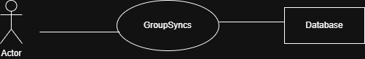
Figure 1: Level 0 for GroupSync
Level 1 for GroupSync System
Highlights administrative interactions: Manage Users, Manage System Settings, View Audit Logs.

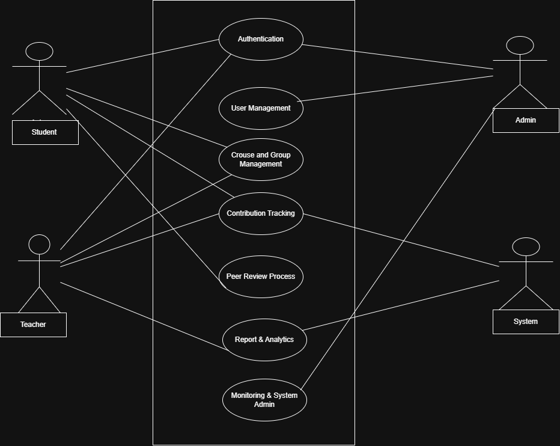
Figure 2: Level 1 for GroupSync

Level 2.1 (Authentication) for GroupSync System
- Defines secure authentication: Sign Up, Sign In, Sign Out, Change Password.
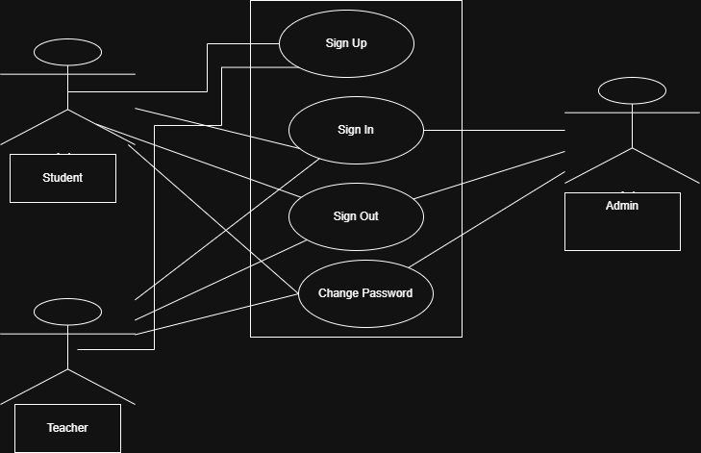
Figure 3: Level 2.1 (Authentication) for GroupSyncs

Level 2.2 (User Management) for GroupSync System
- Represents how Admin creates, updates, and deletes users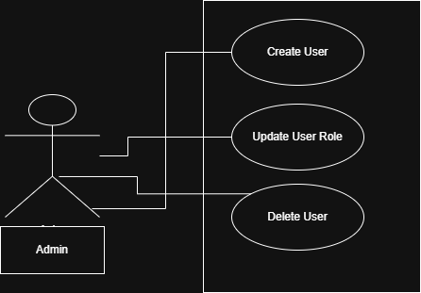.
Figure 4: Level 2.2 (User Management) for GroupSync
Level 2.3 (Course & Group Management) for GroupSync System
- Describes how Teachers create courses and Students create/join groups.
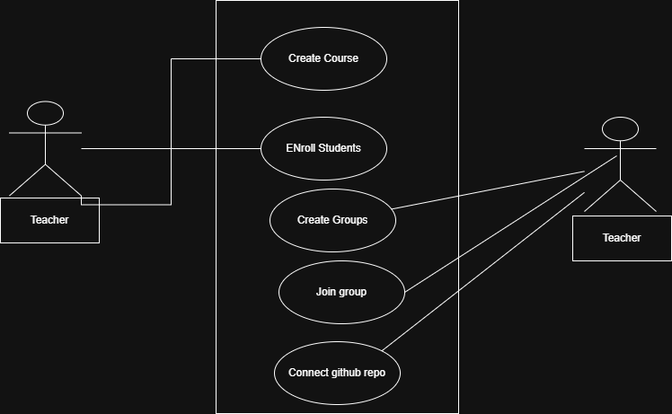
Figure 5: Level 2.3 Course & Group Management for GroupSync
Level 2.4 (Contribution Tracking) for GroupSync System
- Shows Teachers setting weightage and Students viewing their scores.
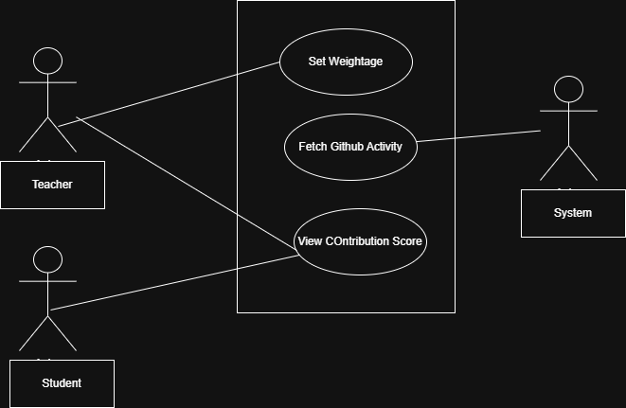
Figure 6: Level 2.3 Contribution Tracking for GroupSync

Level 2.5 (Peer Review Process) for GroupSync System
- Illustrates how Students submit anonymous peer reviews.
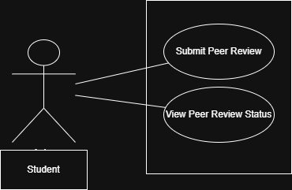
Figure 7: Level 2.3 Peer Review Process for GroupSync

Level 2.6 (Report & Analytics) for GroupSync System
- Shows Teachers generating reports and viewing analytics dashboards.
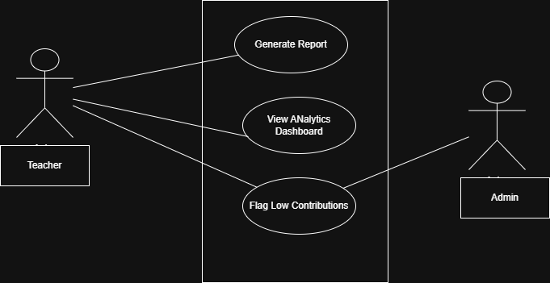
Figure 8: Level 2.3 Report & Analytics for GroupSync

Figure 9: Level 2.7 (Monitoring & Admin) for GroupSync System
- Covers Admin monitoring logs and managing system settings.
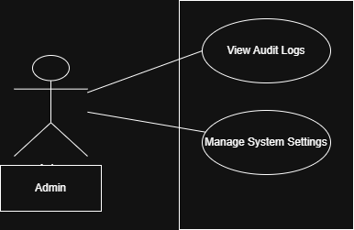

Figure 8: Level 2.3 Monitoring & Admin for GroupSync

6. Class-Based Modeling
Class-based modeling defines the structure of the entire system by identifying the static structure of objects in that system. A class model defines attributes and operations for the objects of each class and also the relationship between the objects, and the collaborations that occur between the classes of the systems. The elements of a class-based model include classes and objects, attributes, operations, Class- Responsibility Collaborator (CRC) models, collaboration diagrams, and packages
6.1 Step-1: Identifying and Categorizing All Nouns
Table 1: Categorization of Identified Nouns
Category | Identified Nouns
External Entities | Student, Teacher, Admin, Database, Interface, GitHub API
Things | Course, Group, Project, Contribution Score, Peer Review, Report, Repository, Weightage, Notification, Audit Log
Occurrences / Events | Login, Register, Create Group, Join Group, Submit Review, Fetch Commits, Generate Report, Flag Contributor
Roles | Student, Teacher, Admin
Organizational Units | University, Department, Course Code
Places | Database, Server, GitHub Cloud
Structures | System, Dashboard, Analytics Chart

6.2 Step-2: Selection of Potential Classes
The identified nouns from Step-1 were systematically evaluated to determine whether they qualify as potential classes in the object-oriented design of the GroupSync System. The selection was based on the following standard class selection criteria:
Criterion | Description
1. Retained Information | The noun represents data that must be stored persistently in the system.
2. Needed Services | The noun requires specific operations or behaviors to be performed on or by it.
3. Multiple Attributes | The noun has multiple relevant properties that describe it.
4. Common Attributes | The noun shares attributes with other nouns, suggesting a potential inheritance hierarchy.
5. Common Operations | The noun shares operations with other nouns, suggesting a potential inheritance hierarchy.
6. Essential System Requirement | The noun is explicitly required by stakeholders or system specifications.

6.2.1 Potential Class Selection Table
Table: Potential Class Selection and Evaluation Status for GroupSync System
Sl. No | Potential Class (Noun) | Status
1 | User | Accepted
2 | Admin | Accepted
3 | Teacher | Accepted
4 | Student | Accepted
5 | Course | Accepted
6 | Group | Accepted
7 | ProjectAssignment | Accepted
8 | ContributionScore | Accepted
9 | PeerReview | Accepted
10 | GitHubRepo | Accepted
11 | Report | Accepted
12 | Notification | Accepted
13 | AuditLog | Accepted
14 | Repository (abstract) | Rejected .  Fails criteria 3, 4, and 5.
15 | Weightage | Rejected. Fails criteria 1, 2, and 6.
16 | Interface | Rejected. Fails criteria 1, 2, and 6.
17 | GitHub API | Rejected.Fails criteria 1, 3, and 4.
18 | Database | Rejected.Fails criteria 2 and 5.
19 | Server | Rejected. Fails criteria 1, 2, and 6.
20 | University | Rejected. Fails criteria 2, 3, and 5.
21 | Department | Rejected.Fails criteria 2, 3, and 6.
22 | Course Code | Rejected. Fails criteria 1, 2, and 5.
23 | Dashboard | Rejected.Fails criteria 1, 2, and 6.
24 | Analytics Chart | Rejected.Fails criteria 1, 2, and 4.
25 | Login | Rejected.Fails criteria 1, 3, and 6.
26 | Register | Rejected. Fails criteria 1, 3, and 6.
27 | Create Group | Rejected.Fails criteria 1, 3, and 6.
28 | Join Group | Rejected. Fails criteria 1, 3, and 6.
29 | Submit Review | Rejected.Fails criteria 1, 3, and 6.
30 | Fetch Commits | Rejected. Fails criteria 1, 3, and 6.
31 | Generate Report | Rejected. Fails criteria 1, 3, and 6.
32 | Flag Contributor | Rejected.Fails criteria 1, 3, and 6.
33 | System | Rejected. Fails criteria 2, 3, and 5.
34 | GitHub Cloud | Rejected. Fails criteria 1, 2, and 3.
6.3 Class Based Modeling Diagram
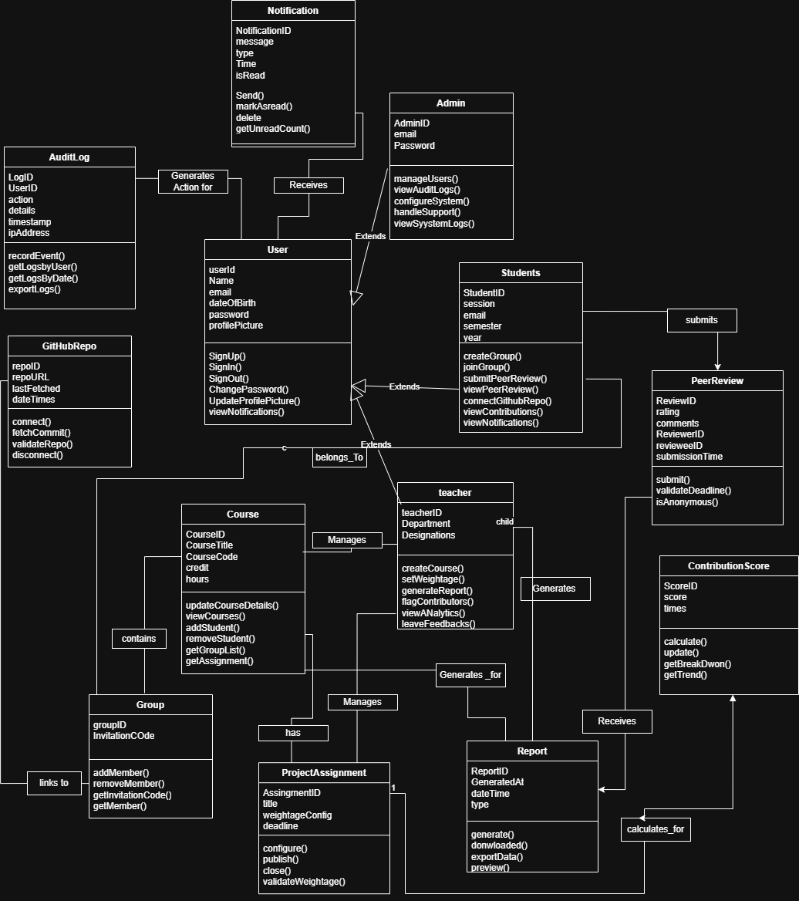
Figure 1: Class Based Modeling Diagram of the GroupSync

7. System Data Flow Modeling
In this section, the structured data flow and architectural boundaries of the GroupSync system are illustrated using Data Flow Diagrams (DFDs). These diagrams complement the object-oriented models (Use Cases and Classes) by showing how data moves, changes, and is stored across various system processes.

7.1 Context Diagram (Level 0 DFD)
The Context Diagram represents the highest-level operational view of the GroupSync system. It defines the system boundary and captures the direct interaction and data exchange between the centralized platform and external entities, including Students, Teachers, Administrators, and the GitHub REST API.
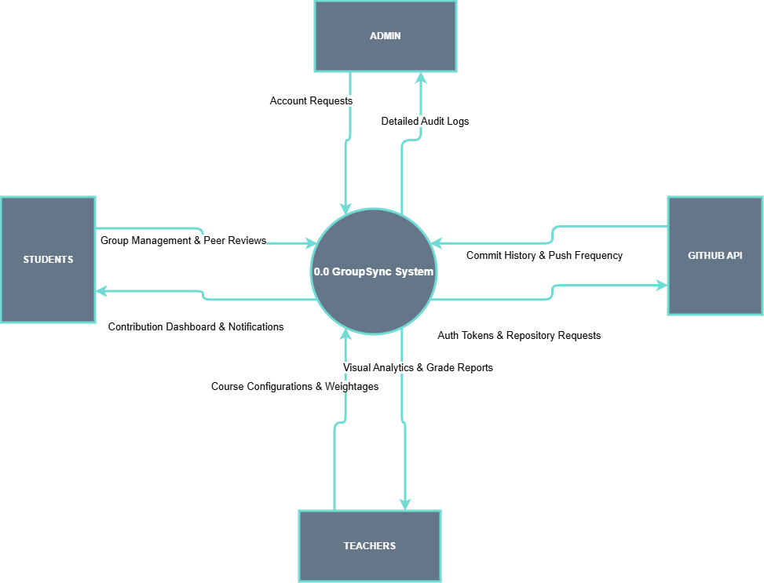

7.2 Level 1 Data Flow Diagram (DFD)
The Level 1 DFD deconstructs the main system into its core functional processes: User Authentication (1.0), Course & Group Setup (2.0), GitHub Activity Fetcher (3.0), Peer Evaluation & Score Engine (4.0), and Analytics & Report Gen (5.0). It maps the detailed data routing into and out of the internal data stores (D1 to D5).

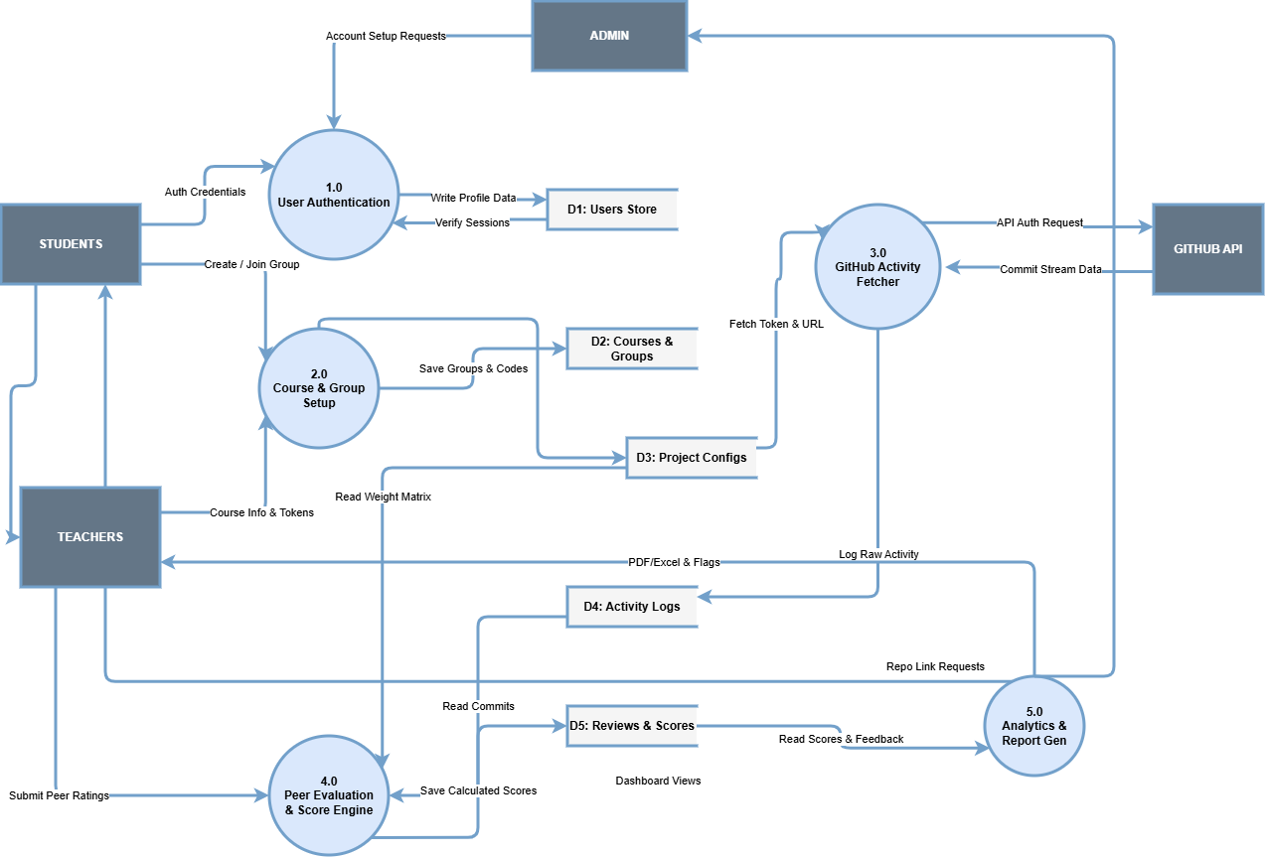

7.3 Level 2 DFD (Process 4.0 - Peer Evaluation & Score Engine)
To isolate and inspect the core algorithmic logic of the platform, Process 4.0 (Peer Evaluation & Score Engine) is exploded into a Level 2 DFD. This diagram tracks the precise sub-processes responsible for fetching metrics, normalizing peer reviews, calculating the final 0-100 contribution score, and triggering automated alerts if a student falls below the teacher-defined threshold.
